

**University of Petroleum and Energy Studies**

**System Provisioning and Configuration Management Lab File**

**Name: Aanchal Tailwal Faculty: Mrs. Silky Goel**

**Branch: BTech CSE**

**Batch: DevOps B-4 (NH)**

**Sap Id: 500097386**

**Roll No: R2142211334**

**INDEX**

|  |  |  |
| --- | --- | --- |
| **S.NO.** | **Name of Experiment** | **Page No.** |
| **1** | Create an IAM account and download and install the Terraform. | **3** |
| **2** | Download Aws provider through terraform | **4** |
| **3** | Write the terraform script to perform some tasks | **8** |
| **4** | Write the terraform script to create the VPC. | **9** |
| **5** | Different types of Variables in Terraform | **11** |
| **6** | Write the script to create multiple instances using the variable having different configurations. | **12** |
| **7** | Write the steps for setting up the Ansible. | **14** |
| **8** | Write an ansible playbook to print hello-world using YML | **15** |
| **9** | Write an ansible playbook and ansible shell commands using yaml. | **16** |
| **10** | Write an ansible playbook to declare variables using yaml. | **17** |
| **11** | Write the playbook to print the default ipv4 address of each host along with the hosts name | **18** |
| **12** | Write the playbook to print the user defined variable from the command line. | **19** |
| **13** | Write the playbook to show the working of loops. | **20** |
| **14** | Write the playbook to pass the multiple variables from the command line. | **22** |

**EXPERIMENT-1**

# AIM : Terraform Installation

**Step 1:** go to https://[www.terraform.io/downloads.html](http://www.terraform.io/downloads.html)

**Step 2:** Scroll down a bit and you can see Windows. There will be 32-bit and 64-bit. As per your

processor, click on the link and the zip file will start getting downloaded. It will be downloaded in your Downloads folder.

**Step 3:** Unzip the zip file.

**Step 4:** Open a command prompt and write the below commands: mkdir terraform cd terraform/

**Step 5:** The zipped file which has been unzipped in Step 3, copy that file and paste it in the folder directory created in step 4.

**Step 6:** In the command prompt window where you entered the commands mentioned in Step 4 just write the below command set PATH=%PATH%;C:\Users\Asus\terraform.

**Step 7:** Now write in the command prompt — terraform. Below is the screenshot of what it looks like

in the machine.

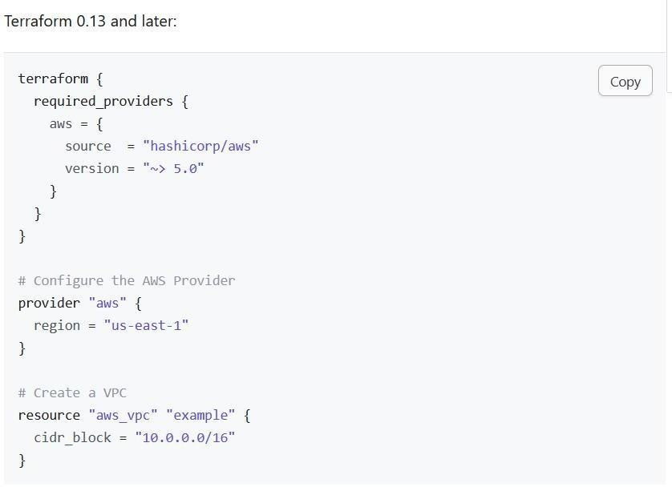

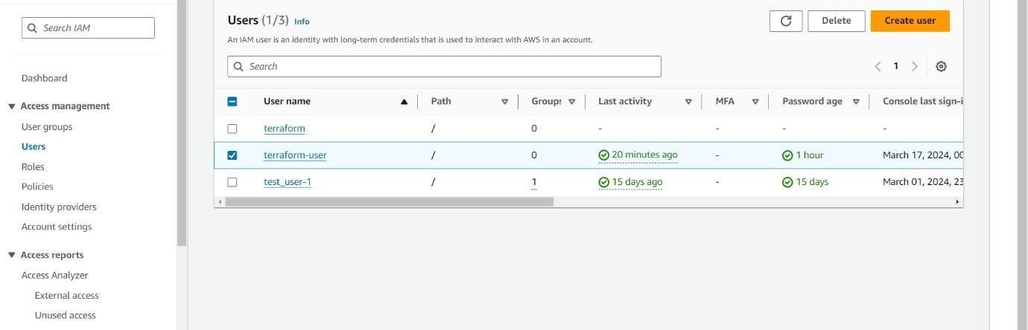

# EXPERIMENT-2

**Aim:**

# Download aws provider through terraform.

* **Provide the aws api access to terraform.**

# Create an EC2 instance.

* **Create an EC2 instance and add a tag.**

Created IAM Admin User — terraform-user

Then Created AWS API Access key for IAM User — terraform-user

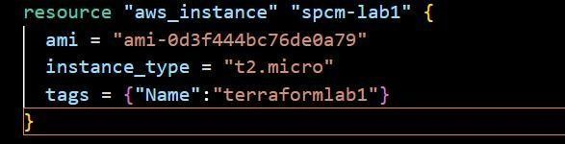

# Terraform commands

1. **terraform init:** This command is responsible for downloading all the dependencies which are required for the provider AWS on your local machine.

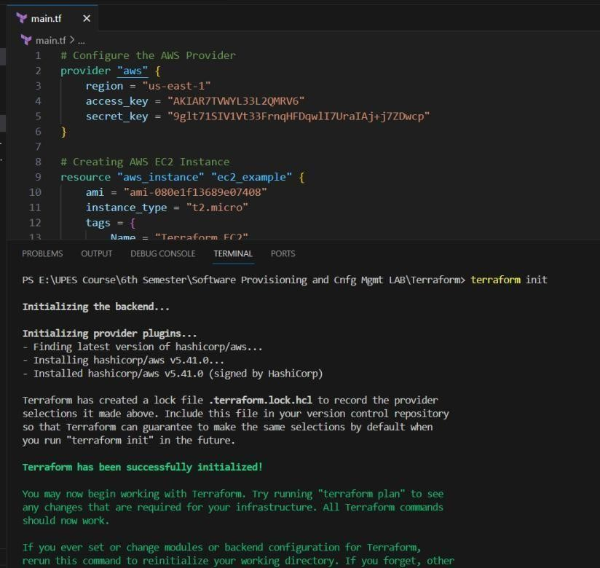

1. 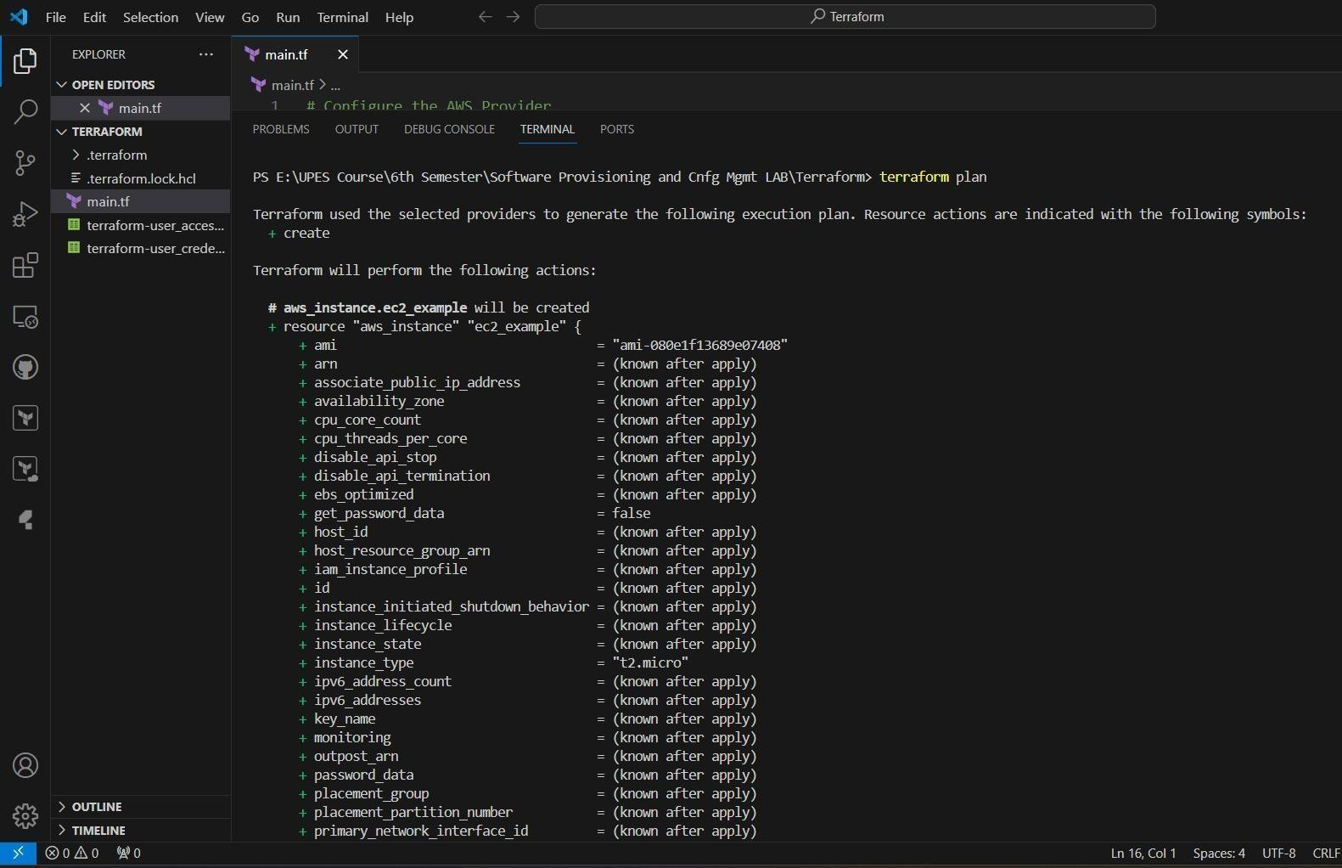**terraform plan:** This command will help you to understand how many resources you are gonna add or delete.
2. **terraform apply:** This command will do some real stuff on AWS. Once you issue this command, it will be going to connect to AWS and then finally going to provision AWS instances.

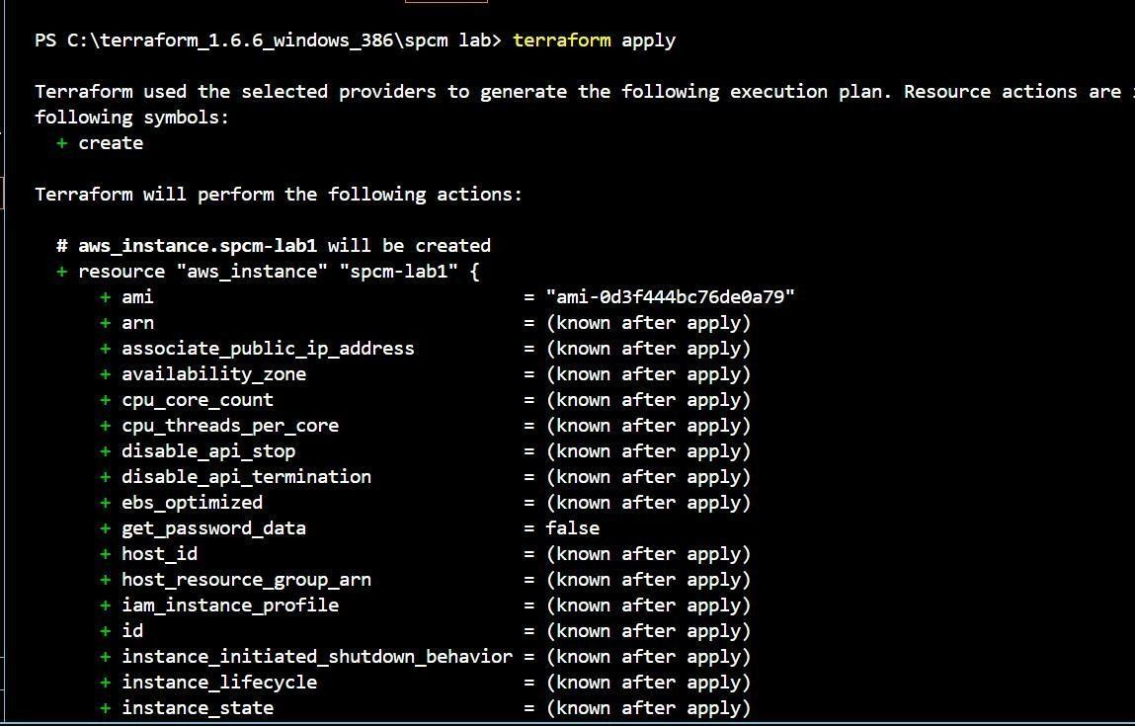

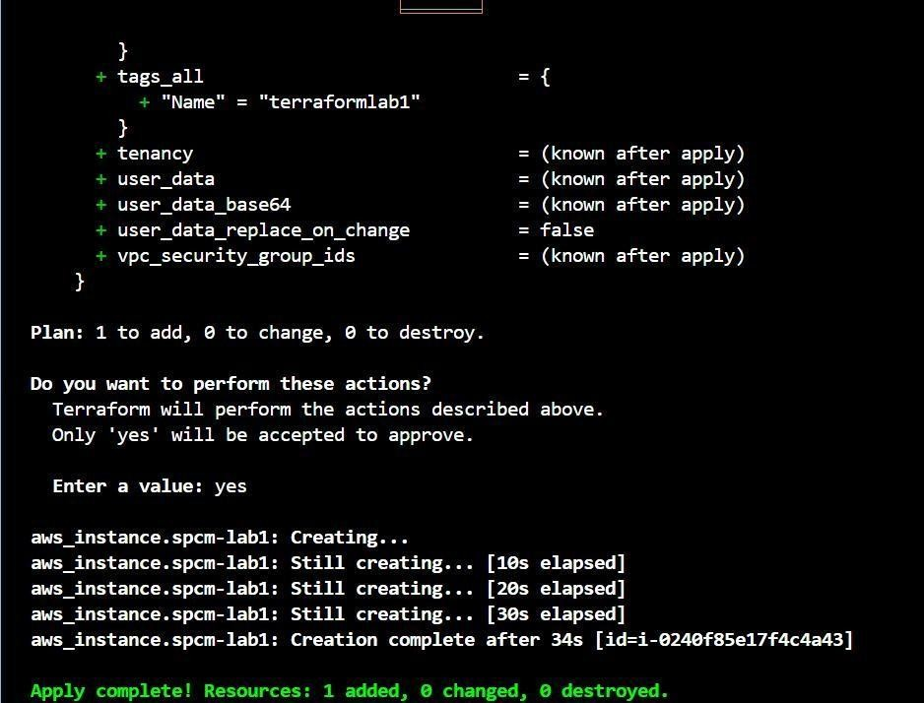

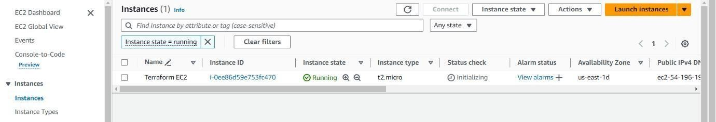

1. **terraform destroy:** It will remove all the running EC2 Instances.

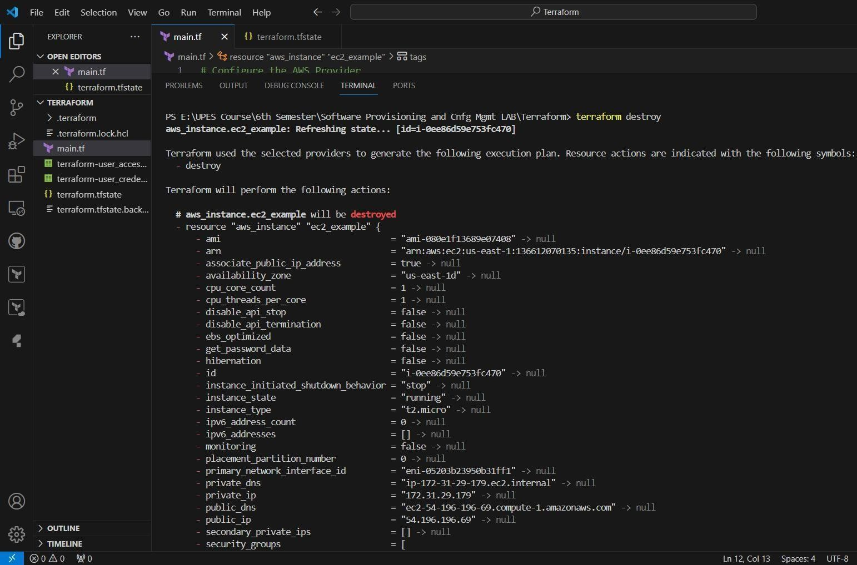

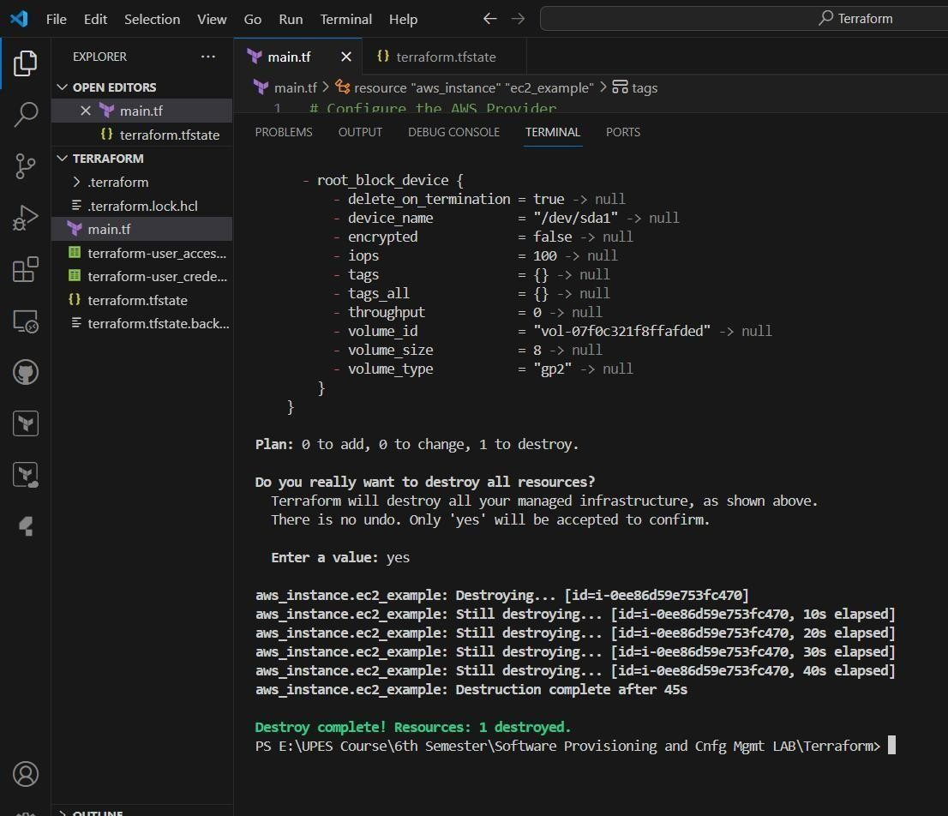

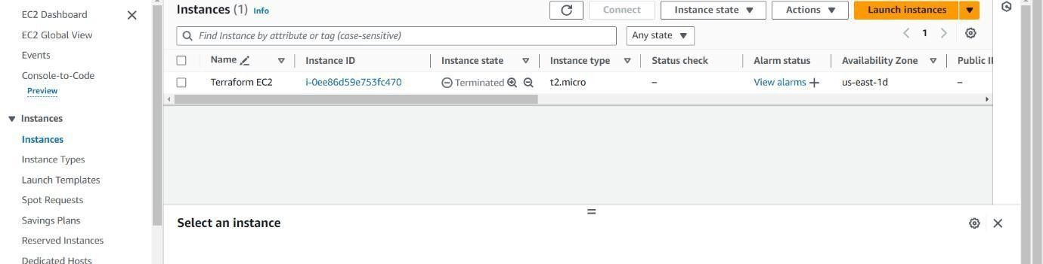

# Experiment- 3

**Aim:**

# Write the terraform script to perform the following task:

* **create a S3 bucket**

# enable the version of the bucket

* **add an upload folder**

Terraform script:

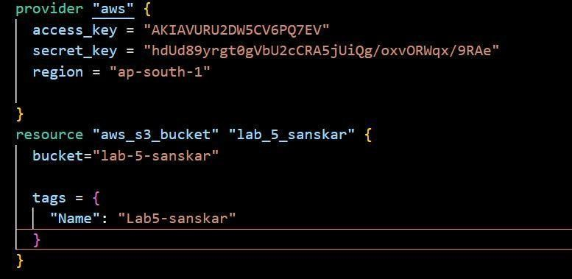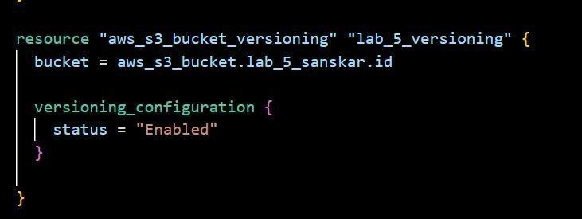

# EXPERIMENT- 4

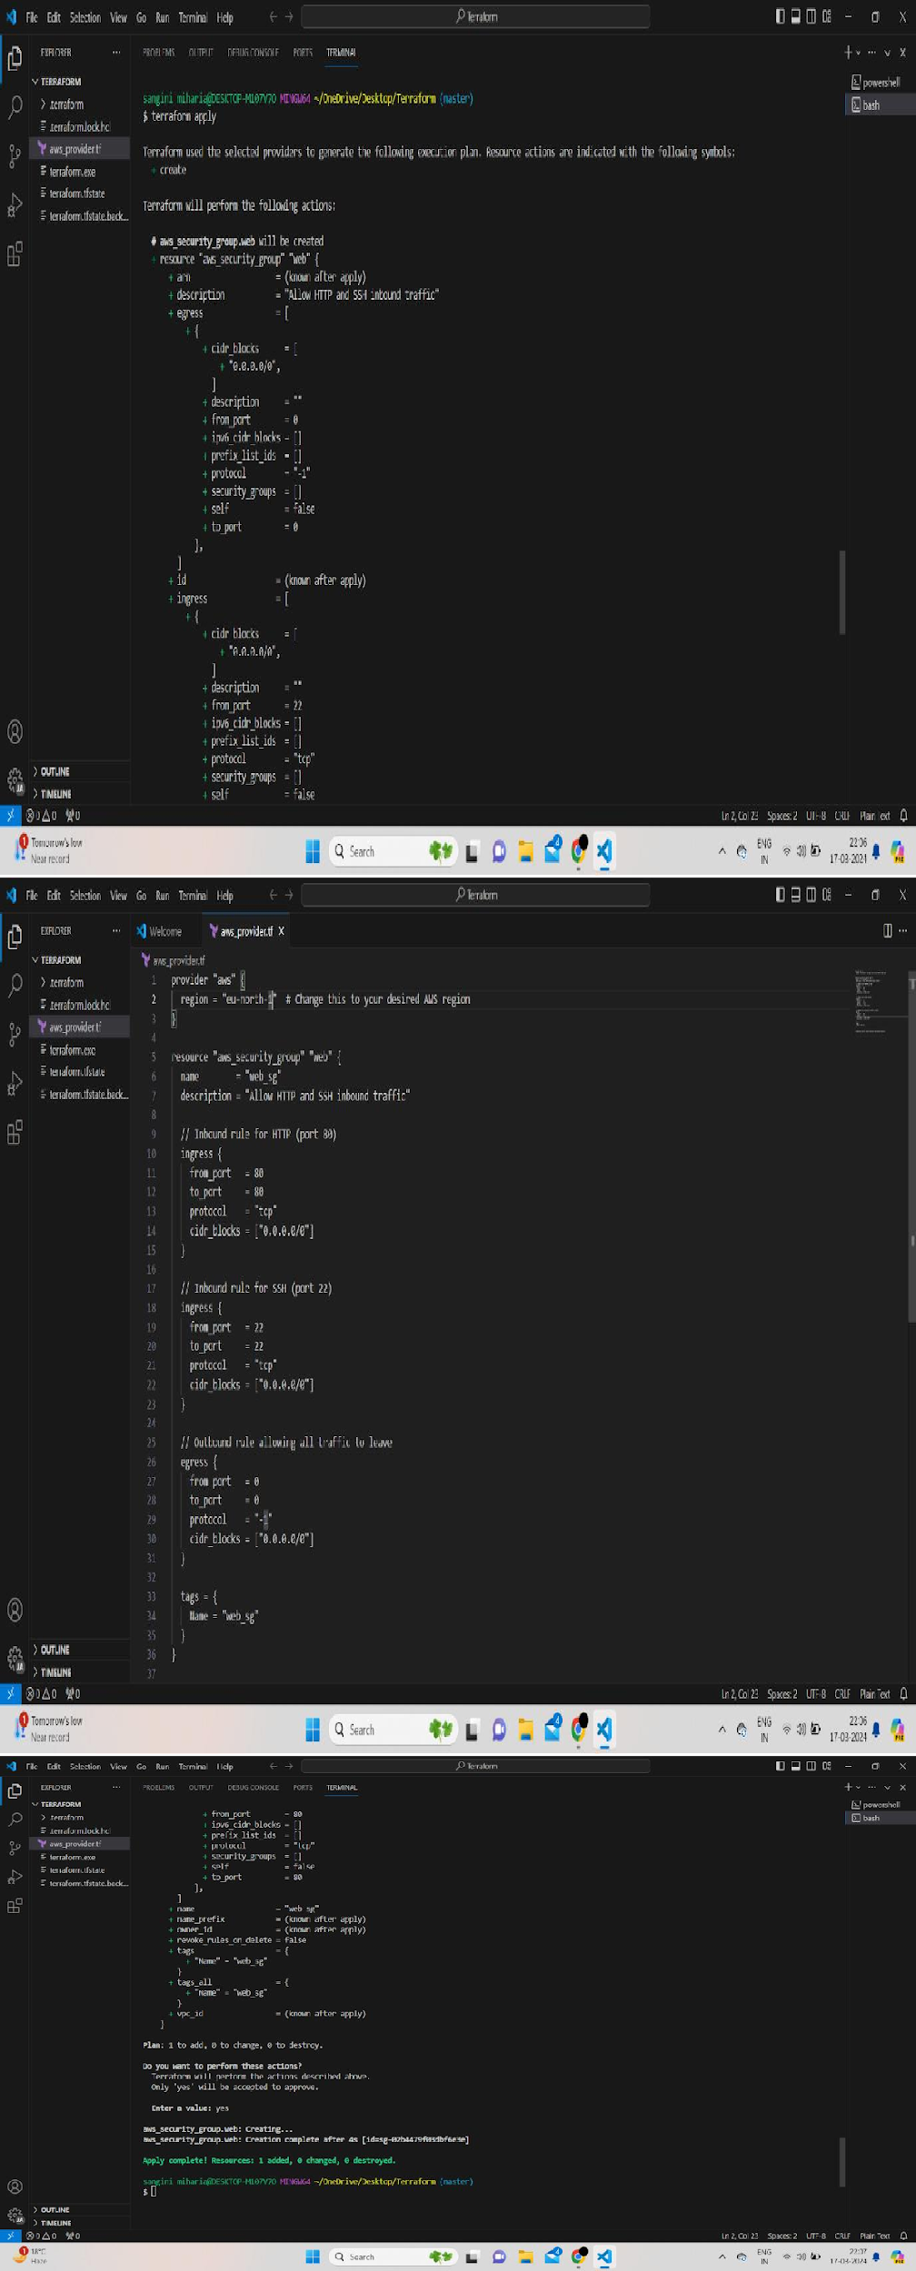AIM: Create Security Group on AWS using Terraform

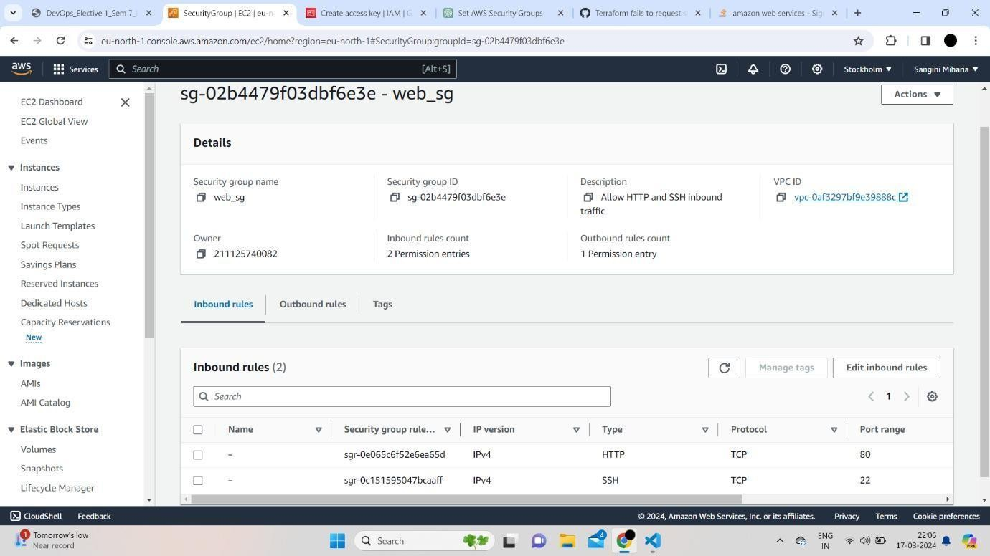

# EXPERIMENT- 5

**Aim:**

# Write the terraform script to create the VPC.

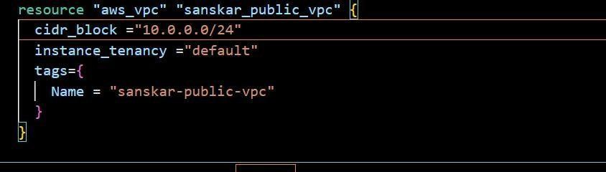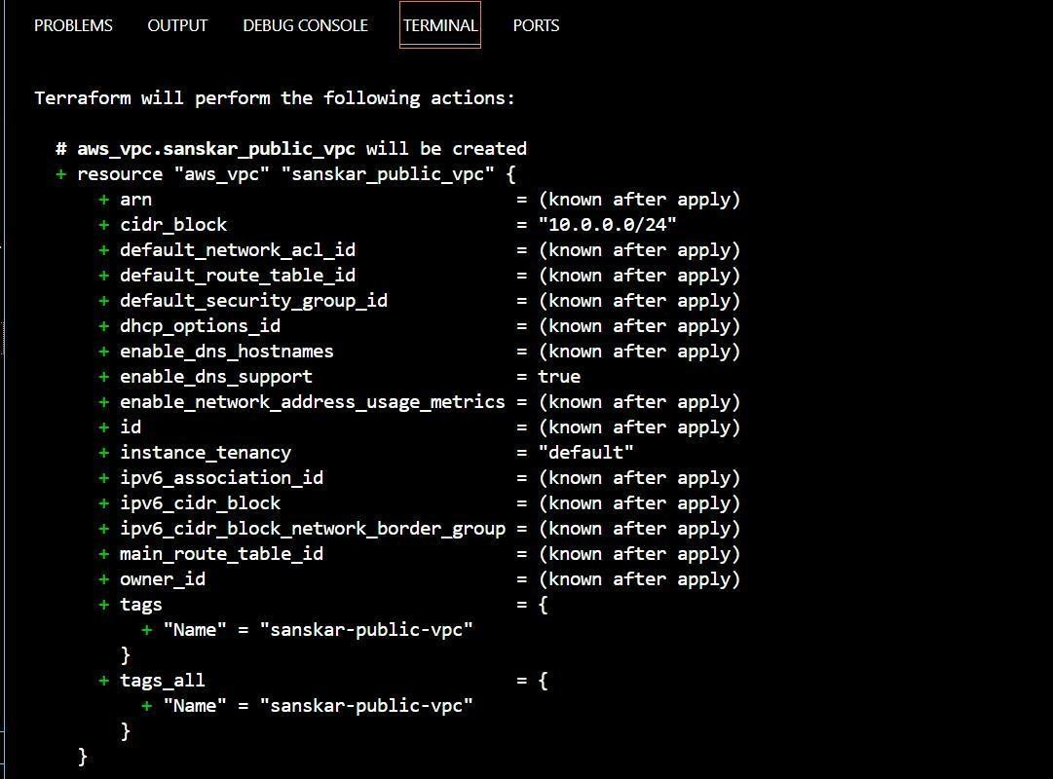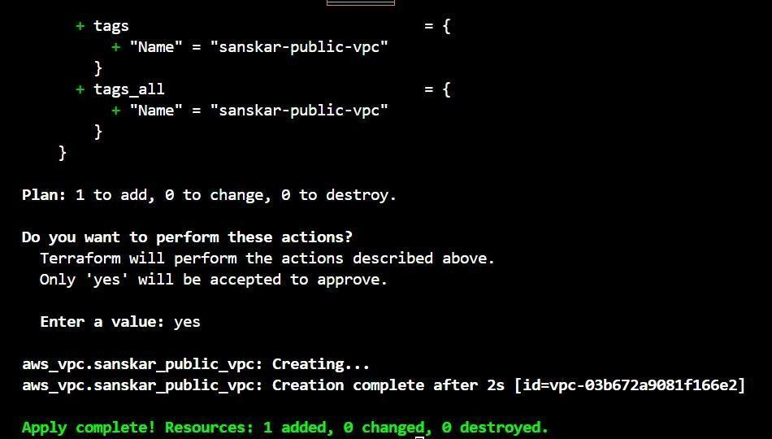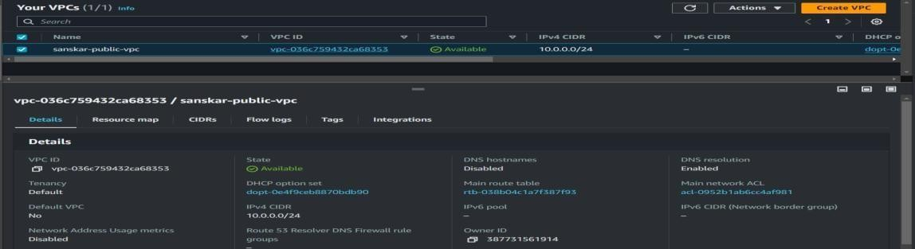

**EXPERIMENT- 6 : Write the script to create multiple instances using the variable having different configurations.**

# Aim:

**1) Variables**

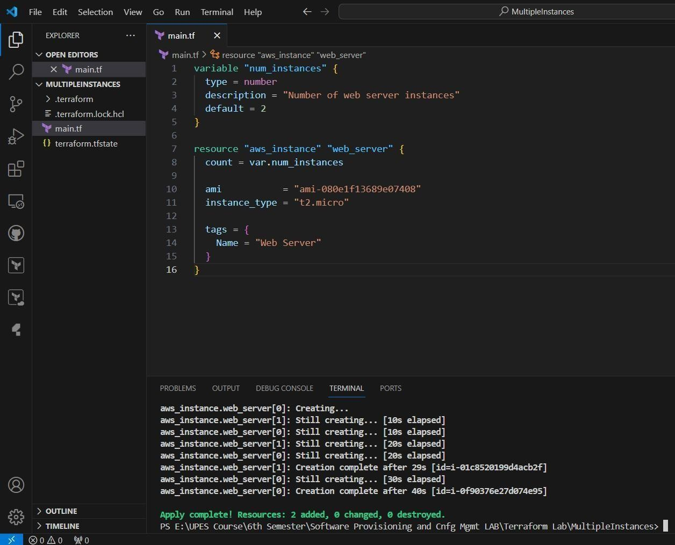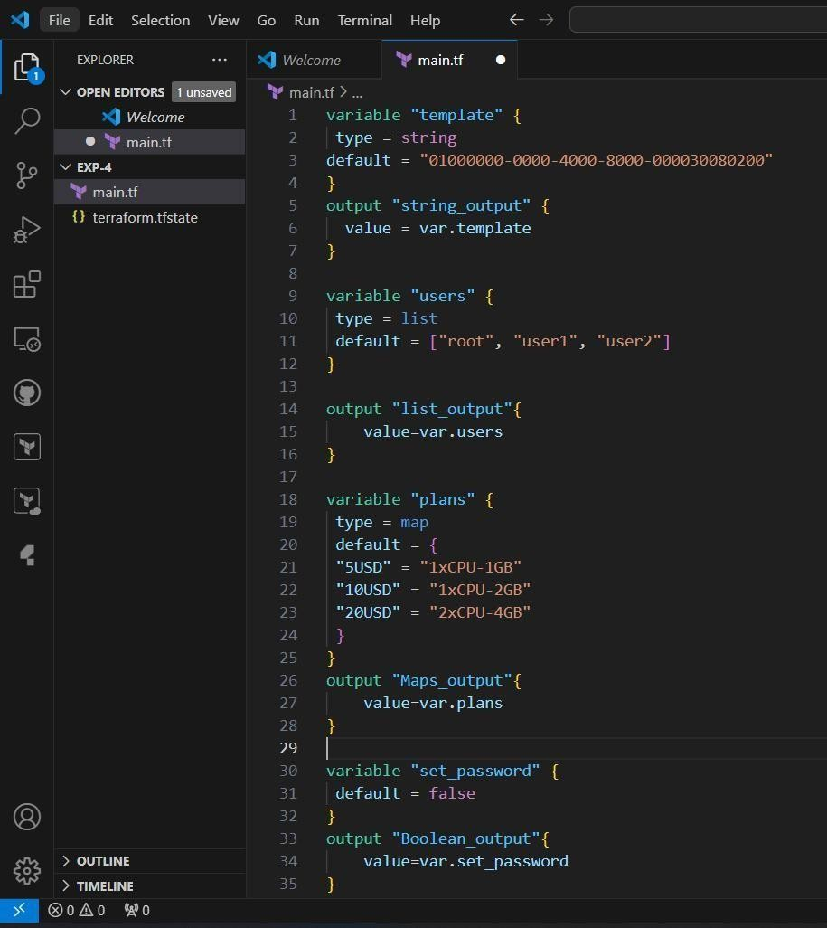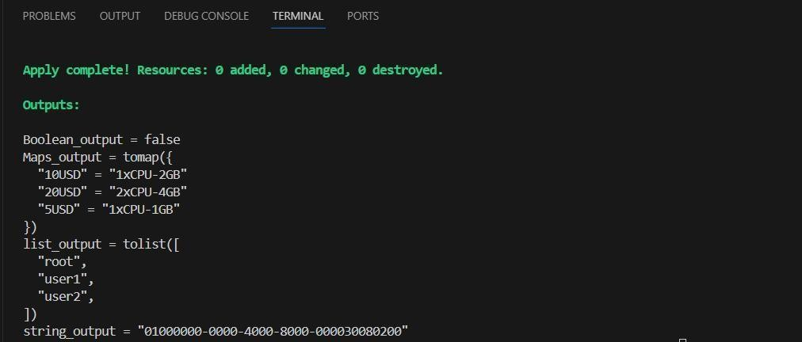

**2) Create multiple instances using the variable**

# Create multiple instances using the variable having different configurations

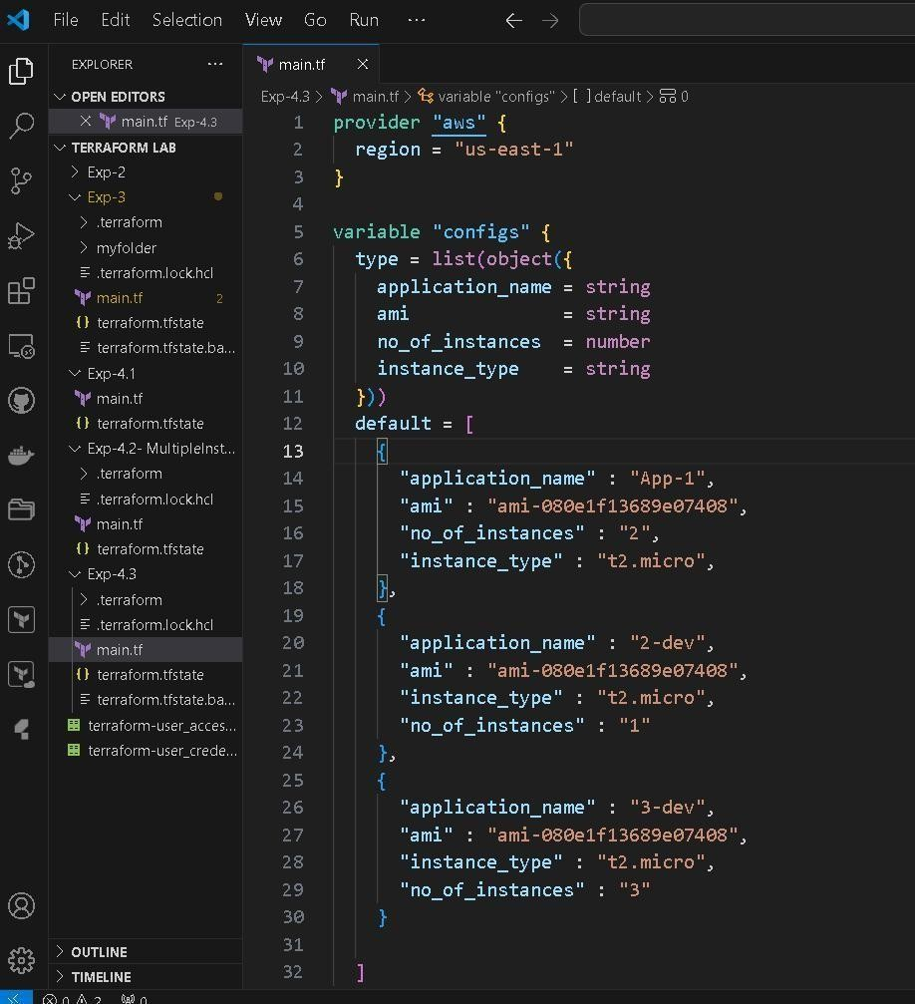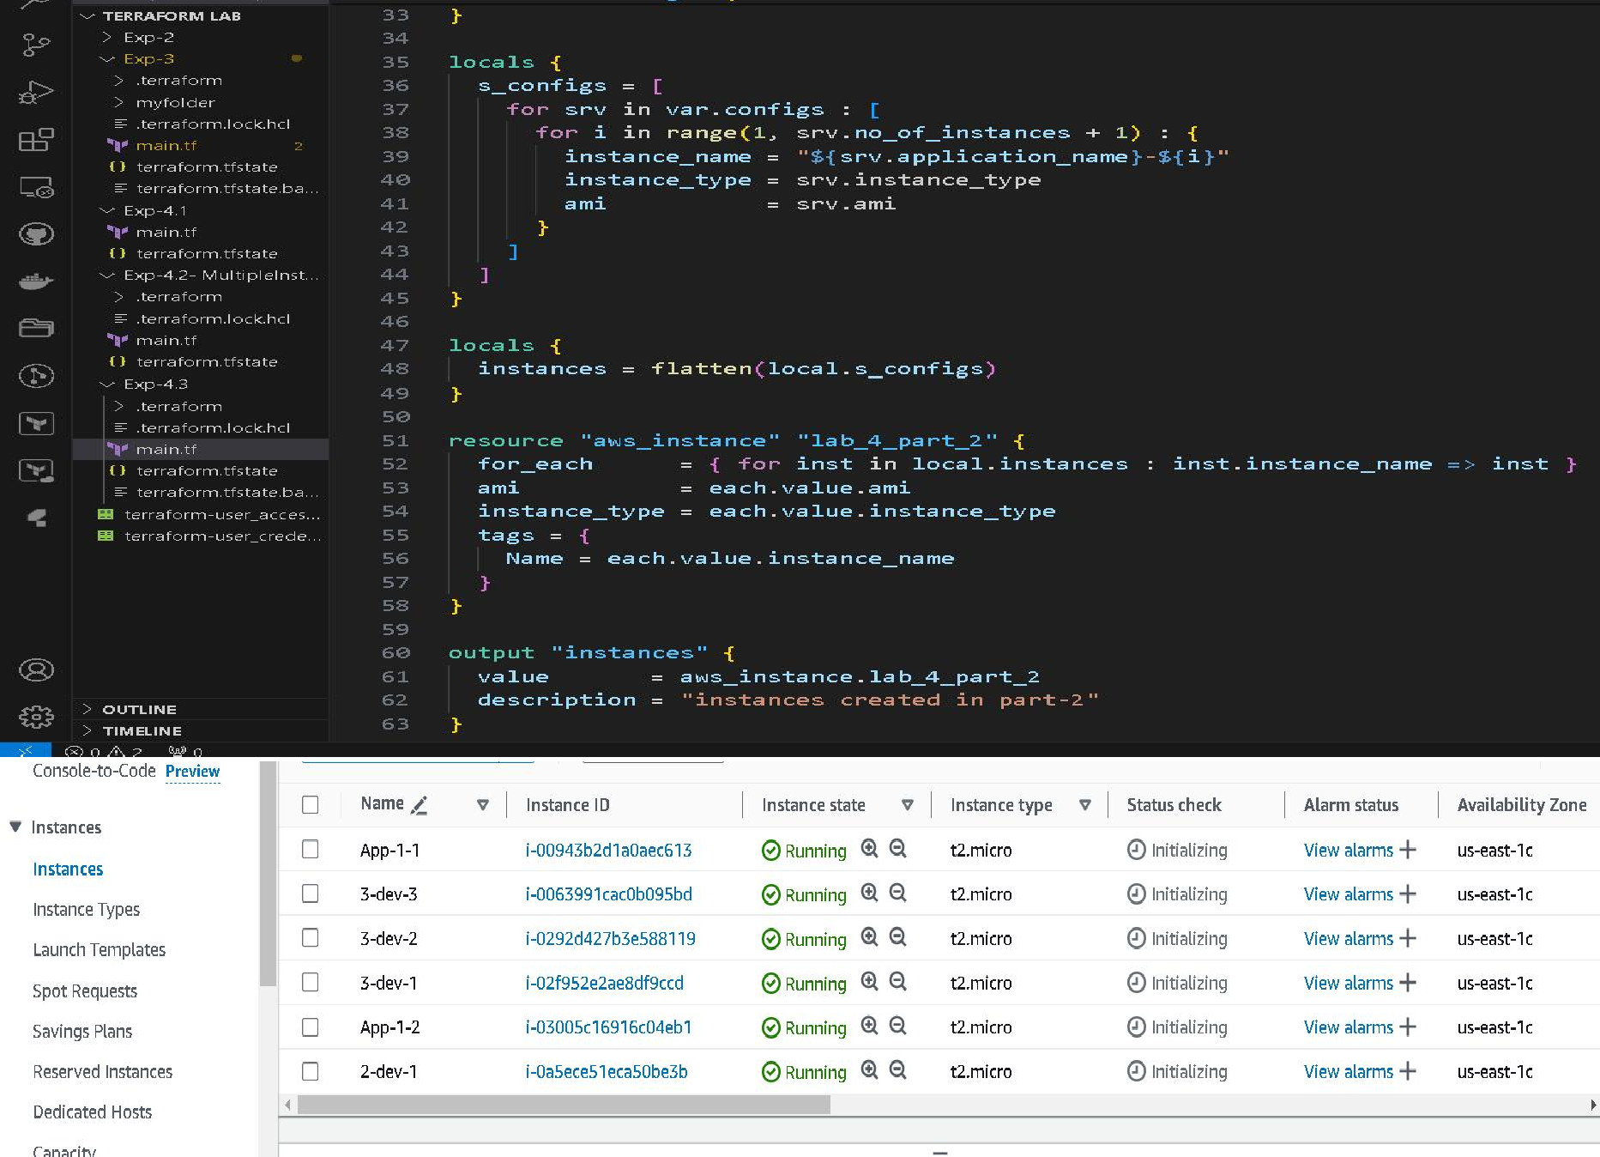

# EXPERIMENT 7

**Write the steps for setting up the Ansible.**

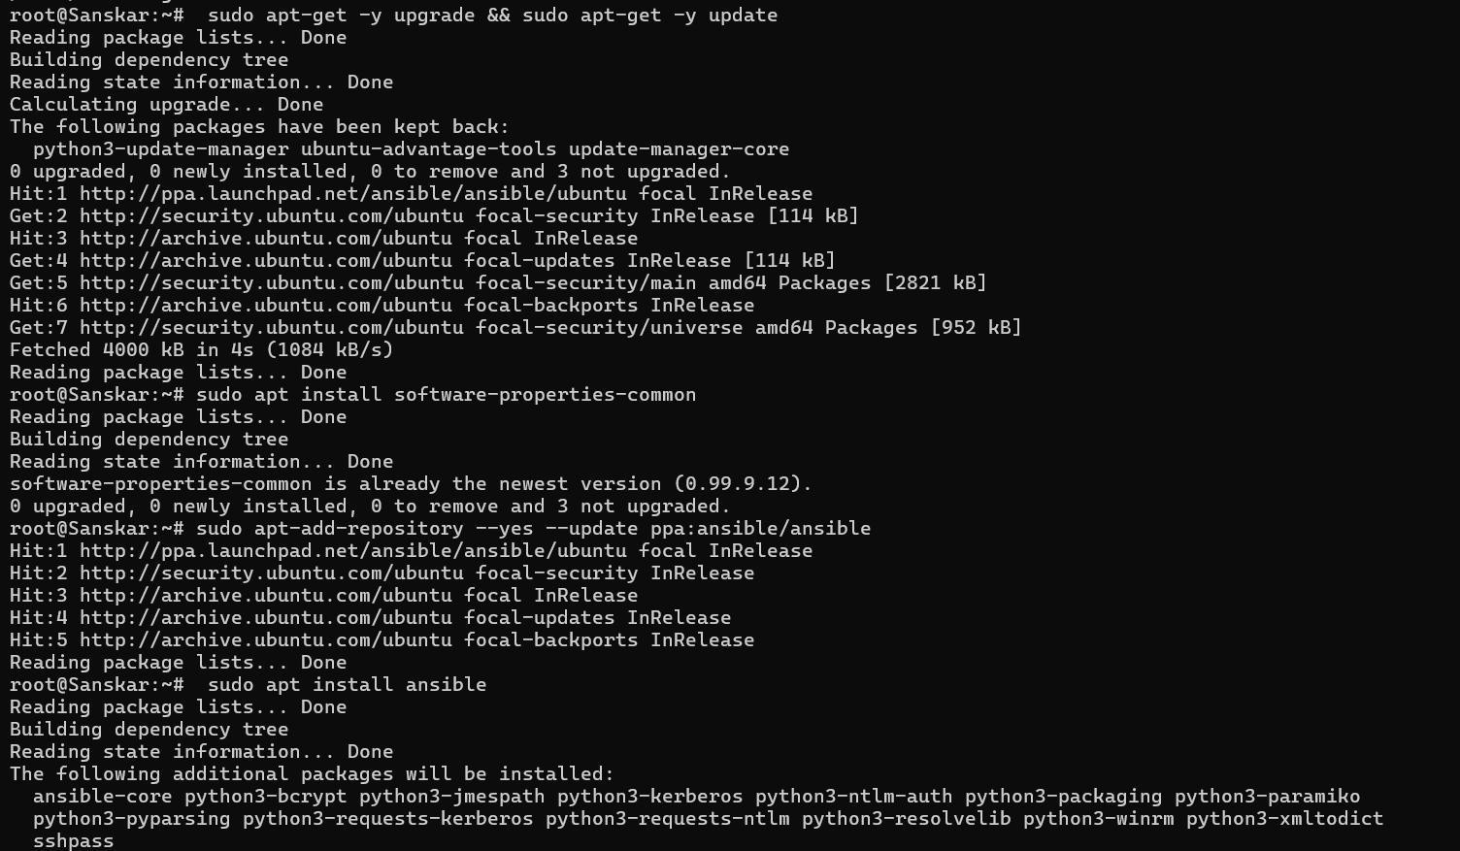**-** sudo apt-get -y upgrade && sudo apt-get -y update

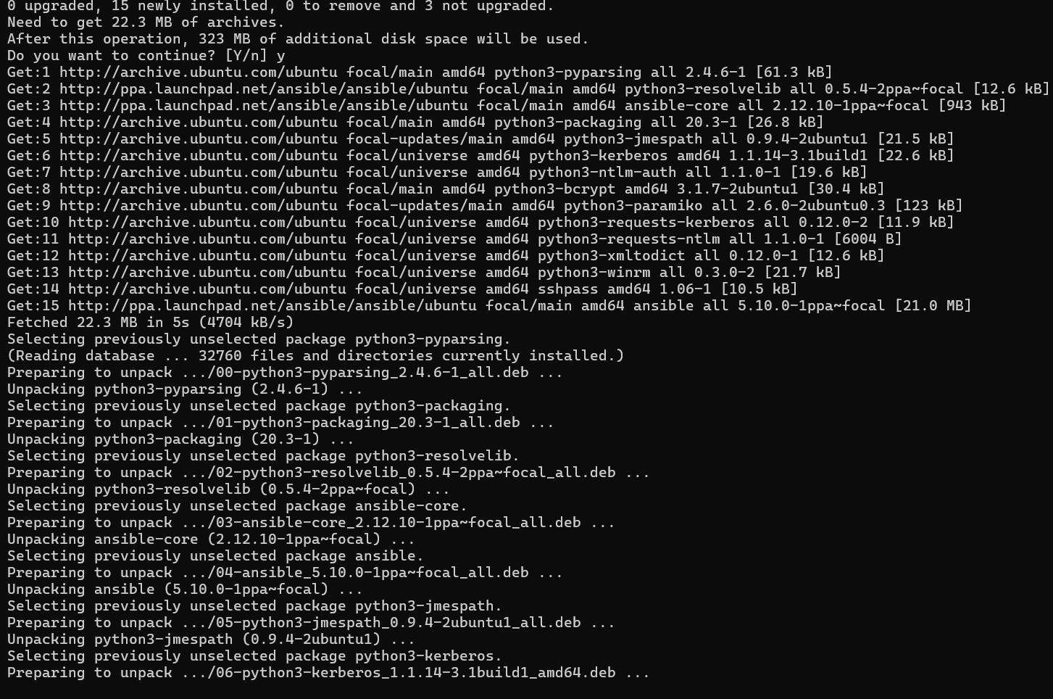- sudo apt install software-properties-common

- sudo apt-add-repository --yes --update ppa:ansible/ansible

- sudo apt install ansible

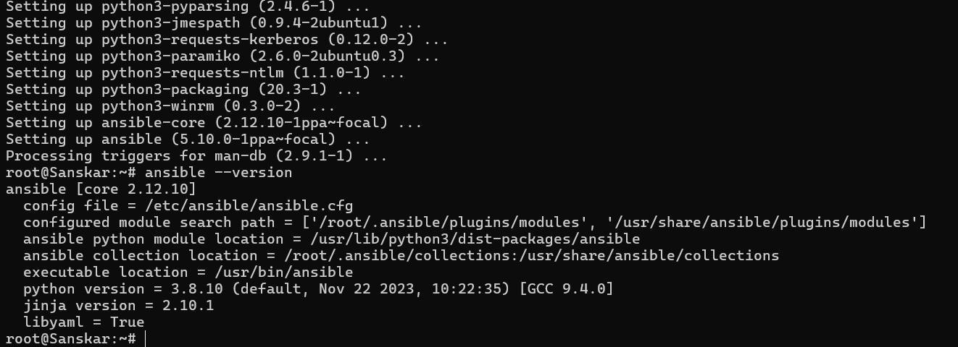

# EXPERIMENT- 8

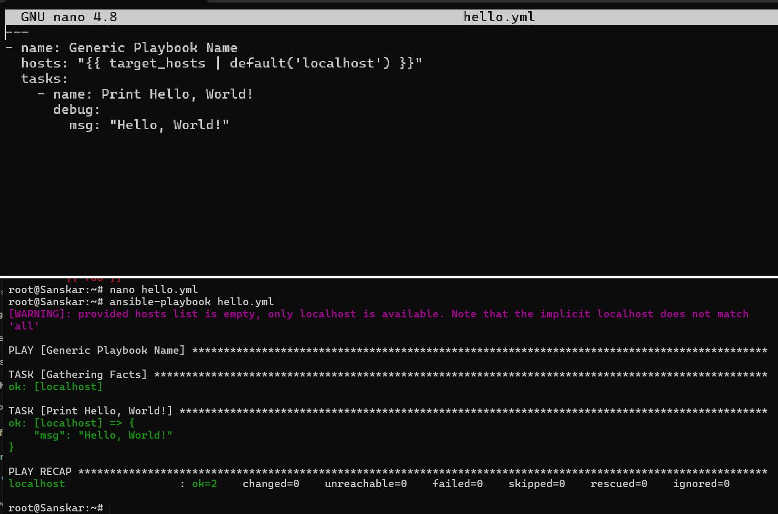WRITE AN ANSIBLE PLAYBOOK TO PRINT HELLO-WORLD USING YML

# EXPERIMENT- 9

WRITE AN ANSIBLE PLAYBOOK AND ANSIBLE SHELL COMMAND USING YAML.

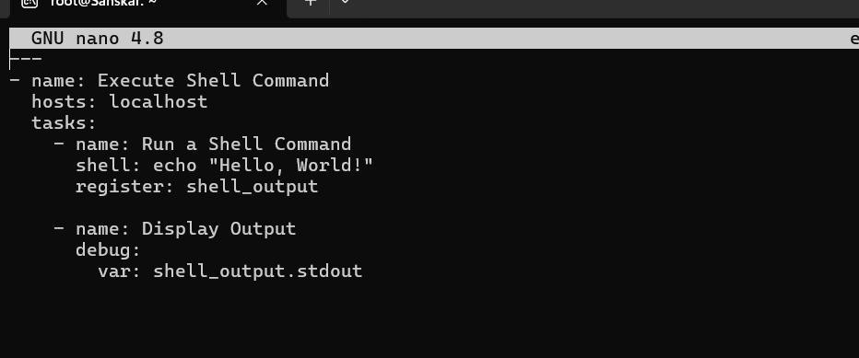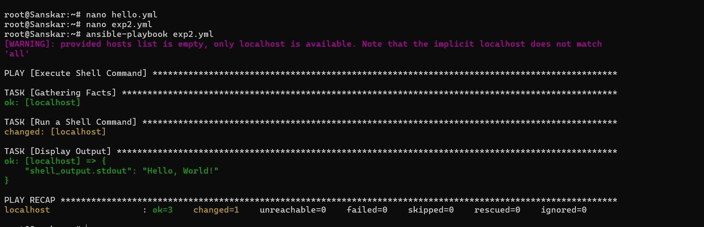

# EXPERIMENT- 10

WRITE AN ANSIBLE PLAYBOOK TO DECLARE THE VARIABLE USING YAML

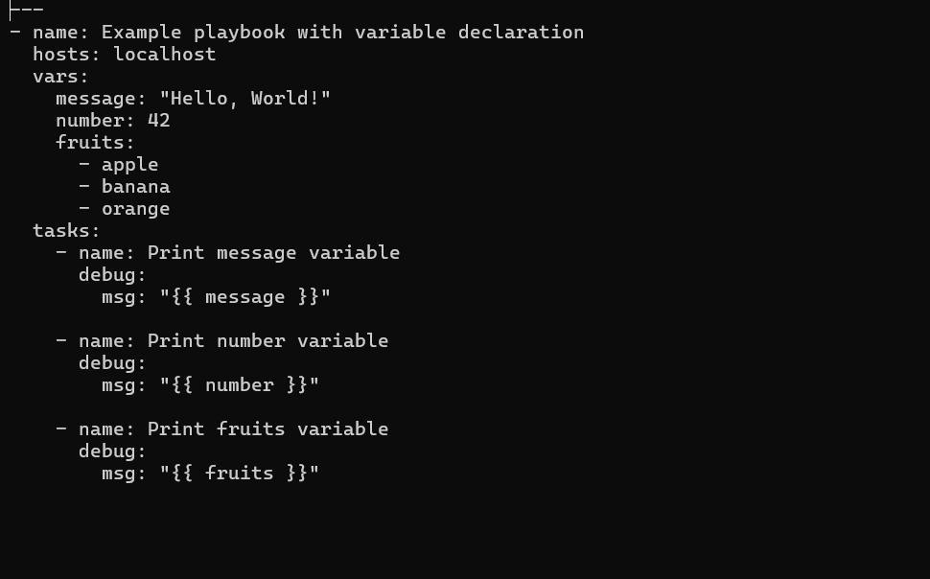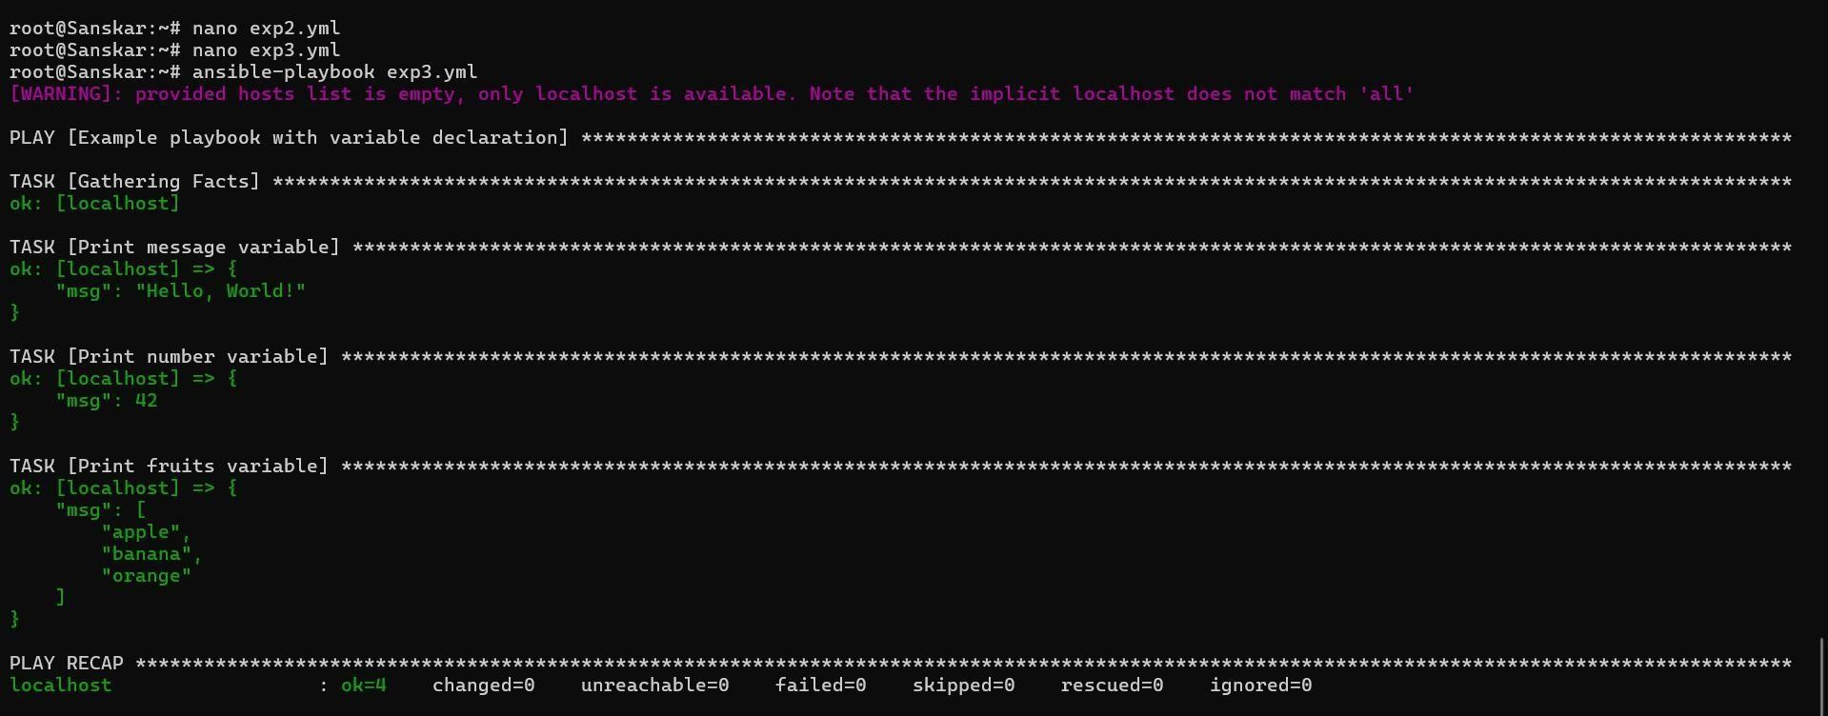

# EXPERIMENT -11

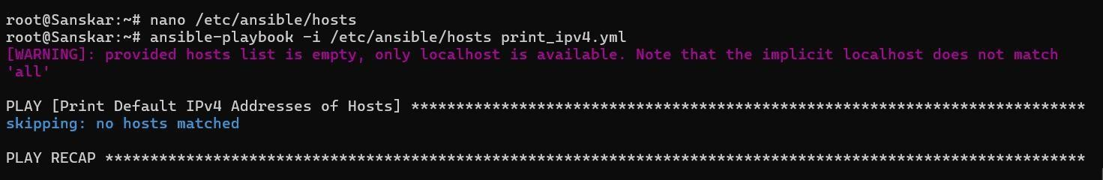1. Write a playbook to print the default ipv4 address of each host along with the host name.

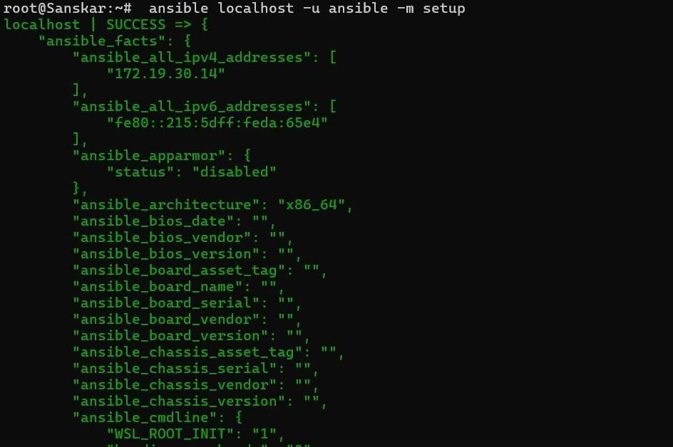Command -: $ ansible localhost -u ansible -m setup

# EXPERIMENT- 12

Write a playbook to print the user defined variables from the command line.

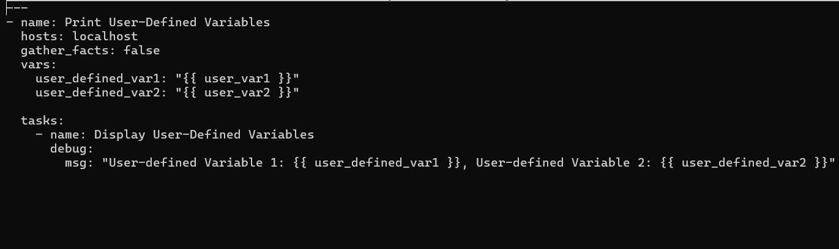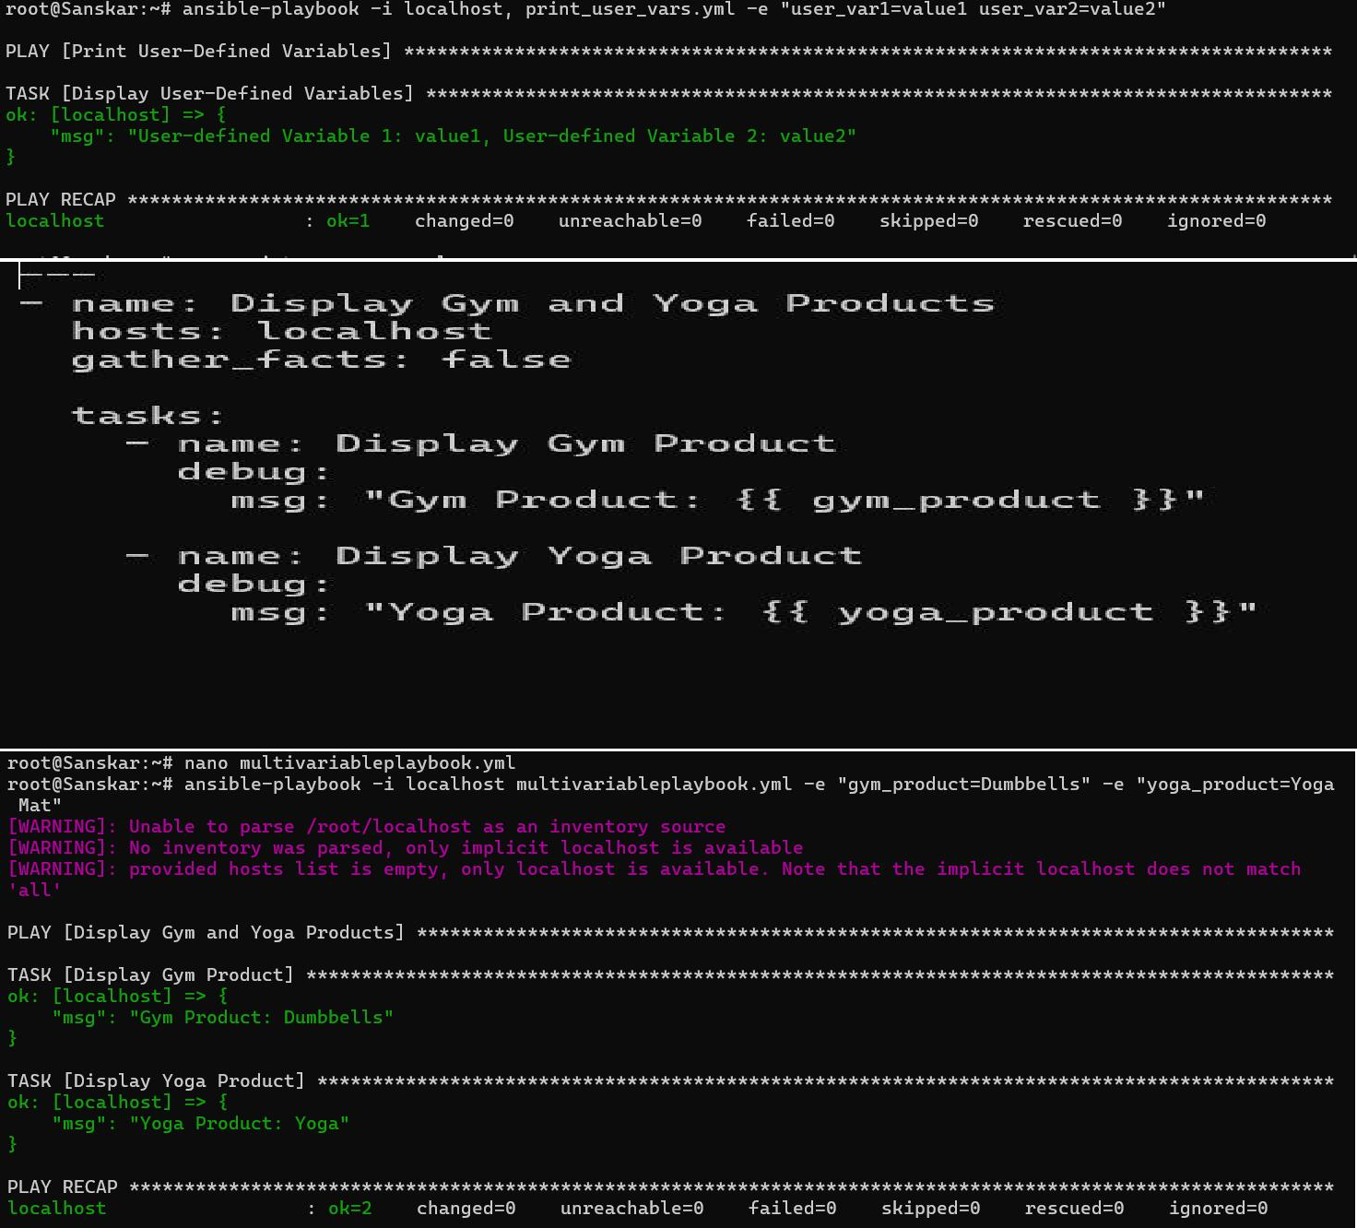

# EXPERIMENT- 13

Write the playbook to show the working of loops.

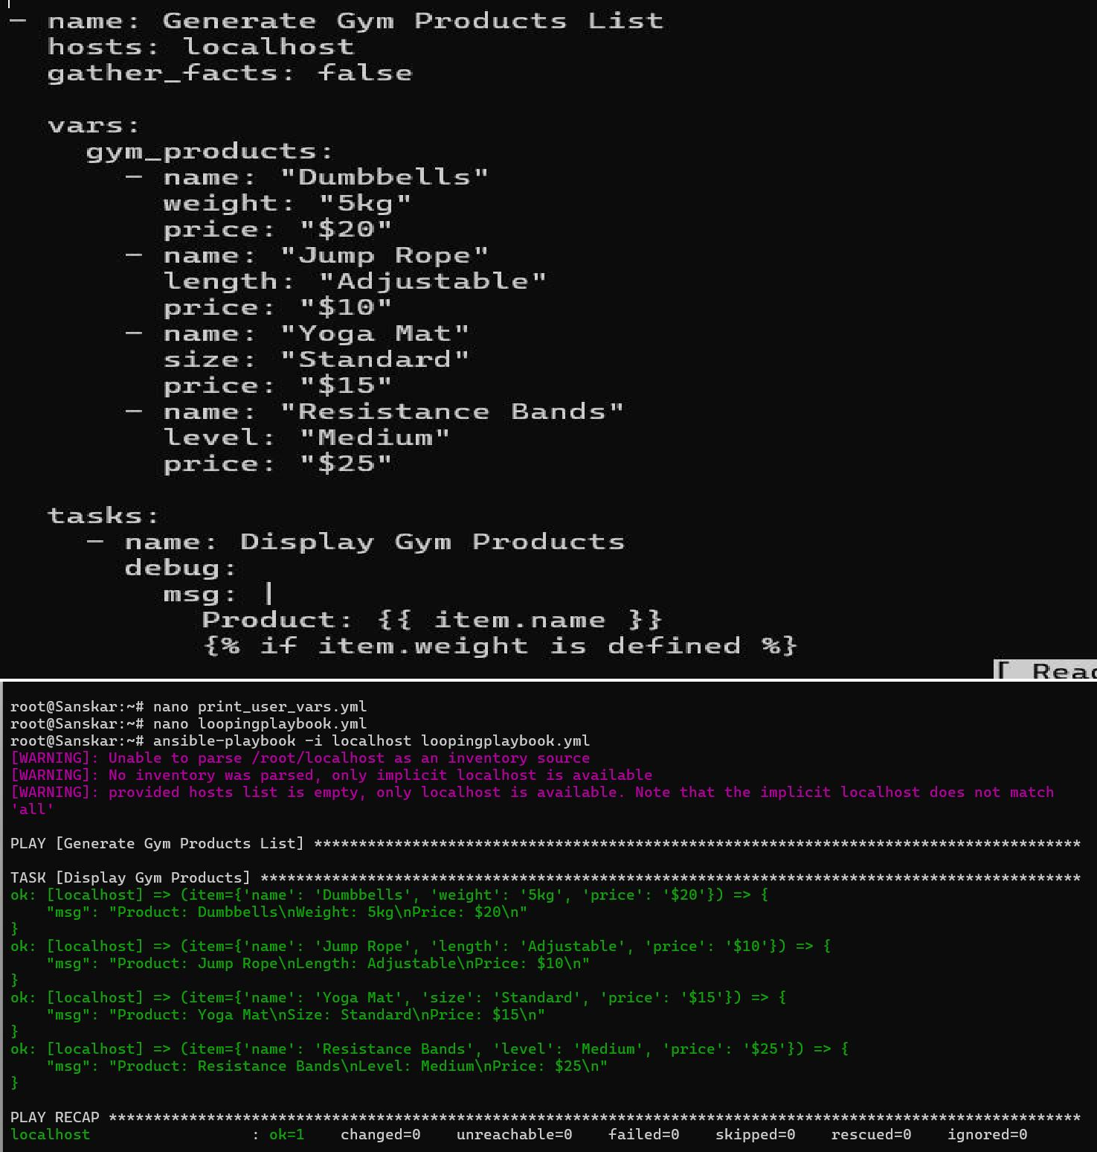

# EXPERIMENT- 14

Write a playbook to print the user defined variables from the command line.

